Logo

Hepatitis C Treatment eSystem
  - Hepatitis C Elimination

Solution Architecture

Author(s) | Gia Jgarkava / Alexander Turdziladze
Enquiries to | Gia Jgarkava / Alexander Turdziladze
Version | 0.5
Status | Initial Draft
Version Date | May 3rd 2018
Comment | Initial Draft of the document to be discussed until the agreement on the document framework and expected content

Revision History
Version | Version Date | Amendments
0.5 | May 3rd 2018 | Initial Draft (Authors – Gia Jgarkava / Alex Turdziladze)

Contents
Acronyms & Abbreviations 3
Index of Figures 4
Index of Tables 4
Purpose of the Document 5
Brief Description of the system functions 5
System Architecture 6
Hepatitis C Ecosystem (AS IS) 6
System Modules / Components (AS IS) 6
Hepatitis C Ecosystem Future Vision (TO BE) 8
System Modules / Components (TO BE) 9
Integrations and dependencies 11
Internal Integrations 11
Internal Dependencies 12
External Integrations 12
Data Access and User Roles 12
Process Workflow 13
Data link to Analytics Module 14
Hardware / Software Requirements 15
Appendix A 17
Appendix B 18

Acronyms & Abbreviations
Hepatitis C / ElimC | Hepatitis C elimination program
Portal / Screening | Hepatitis C Screening System
UMM / UM | User Management Module
CDM / CM | Common Data Module
SB | Service Bus / Integration Bus
MOH / MoLHSA | Ministry of Labour, Healthcare and Social Affairs
SSA | Social Service Agency
NCDC | National Center of Disease Control
CRA | Civil Registry Agency
SDA | Service Development Agency
HCV NSP | National HCV Strategic Plan
CDC | Centers for Disease Control and Prevention
WHO | World Health Organization
HCV | Hepatitis C virus
HPO | Healthcare Provider Organization

Index of Figures
Figure 1. Hepatitis C Program Ecosystem Diagram, indicating the development technology 6
Figure 2. Hepatitis C Program Ecosystem Future Vision 8
Figure 3. Hepatitis C Treatment Business-Process workflow AS IS 14
Figure 4. Hepatitis C Integrated Management Information System - Future Vision 15
Figure 5. Strategies for Hepatitis C Elimination in Georgia 17

Index of Tables
Table 1. NCDC.eHealth modules AS IS 6
Table 2. MOH.ElimC modules AS IS 7
Table 3. MOH.eHealth modules AS IS 7
Table 4. Other modules AS IS 8
Table 5. NCDC.eHealth modules TO BE 10
Table 6. MOH.eHealth modules TO BE 10
Table 7. Data Dictionary for the new Hepatitis C Treatment Integrated Solution 18

Purpose of the Document
The Solution Architecture document defines the technical components of the Hepatitis C treatment system (Hepatitis C Elimination System) overall solution architecture. It is produced during the project implementation phase as part of the design activities.
The document builds on the solution architecture defined in the accompanying Architecture Impact Assessment produced for the project prior to Business Case approval.
The document is produced by a Project Management team and aims to:
- Illustrate the high-level solution architecture and its components from logical, physical, data and interoperability viewpoints.
- Describe the overall solution architecture at a high level sufficient to inform technical contacts who undertook detailed design work.
- Clarify the infrastructure requirements to support detailed infrastructure design activities.
- Demonstrate how the solution has addressed security requirements.
Under the current project it is panned to improve and redesign an existing Hepatitis C Elimination systems to support and increased quantity of performance, safety and productivity challenges.

Brief Description of the system functions
According to the national Strategic Plan for the Elimination of HCV , various information system components were developed, improved and integrated resulting in the Hepatitis C ecosystem. See the Appendix A for the defined Strategies and activities list.
According to the Strategy 3 under the planned activities framework Hepatitis C Screening module was developed as a basis and framework as a future ecosystem . A web-based registry was developed to track screening outcomes among all persons tested for HCV infection. The system collects demographic and risk-factor information and is interoperable with the Hepatitis C platform, facilitating linkage to care for those with positive results. The system allows for efficient program planning and implementation, as well as enable monitoring and evaluation.
The health information system was later expanded to ensure adequate provision of HCV care and treatment. However current health information system (Hepatitis C) needs improvements to enable effective monitoring of the continuum of HCV care and the collection of other data to assess program effectiveness. The system enables tools for the care and treatment activities for all the stakeholders and actors of the program:
- Social Service Agency
  - Head Office
  - Regional Offices
- National Center of Disease Control
- Healthcare Providers
- Pharmacies
- Patients

System Architecture
The redesigned system will follow existing modular approach which means existing of various shared operational resources for the information store, flow and administration.

Hepatitis C Ecosystem (AS IS)
The current Ecosystem of Hepatitis C program consists of the components that are clustered in 4 groups:
- NCDC.eHealth
- MOH.ElimC
- MOH.eHealth
- Other
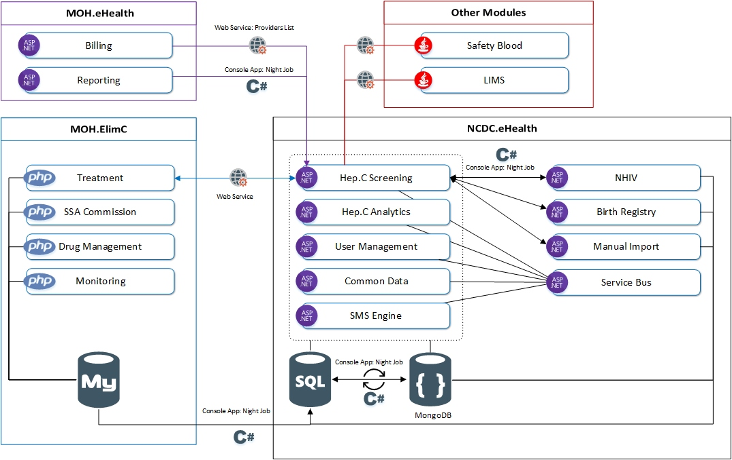
Figure 1 represents the components of Hepatitis C ecosystem and their connections and integrations (Discussed in detail in the Chapter “Integrations and dependencies”, pg. 5).
Figure 1. Hepatitis C Program Ecosystem Diagram, indicating the development technology

System Modules / Components (AS IS)
Table 1. NCDC.eHealth modules AS IS
Component | Platform/Language | Database | Location | Comment
NCDC.eHealth.Screening (Hepatitis C Screening) | ASP.NET Web Forms | Microsoft SQL / MongoDB | MoLHSA Virtual Machine
NCDC.eHealth.Analytics (Hepatitis C Analytics) | ASP.NET Web Forms | Microsoft SQL | MoLHSA Virtual Machine
NCDC.eHealth.UM (User Management) | ASP.NET Web Forms | Microsoft SQL | MoLHSA Virtual Machine | Custom authentication method (similar to oAuth)
NCDC.eHealth.CM (Common Data) | ASP.NET Web Forms | Microsoft SQL | MoLHSA Virtual Machine
NCDC.eHealth.SMS (SMS engine) | ASP.NET Web Forms | Microsoft SQL | MoLHSA Virtual Machine
NCDC.eHealth.NHIV (NCDC NHIV Module) | ASP.NET Web Forms | Microsoft SQL | MoLHSA Virtual Machine
NCDC.eHealth.BR (NCDC Birth Registry) | ASP.NET Web Forms | Microsoft SQL | MoLHSA Virtual Machine
NCDC.eHealth.SB (Service Bus / Messagin Module) | ASP.NET Web Forms | Microsoft SQL | MoLHSA Virtual Machine

Table 2. MOH.ElimC modules AS IS
Component | Platform/Language | Database | Location | Comment
MOH.ElimC.Treatment (Elimination C Treatment) | php | mysql | MoLHSA Virtual Machine
MOH.ElimC.Commission (SSA Commission) | php | mysql | MoLHSA Virtual Machine
MOH.ElimC.Drugs (Drug Management / Stock) | php | mysql | MoLHSA Virtual Machine
MOH.ElimC.Monitoring (Hepatitis C Monitoring) | php | mysql | MoLHSA Virtual Machine

Table 3. MOH.eHealth modules AS IS
Component | Platform/Language | Database | Location | Comment
MOH.eHealth.Billing (Billing Module) | ASP.NET Web Forms | Microsoft SQL / MongoDB | MoLHSA Virtual Machine
NCDC.eHealth.Reporting (Reporting Module) | ASP.NET Web Forms | Microsoft SQL | MoLHSA Virtual Machine

Table 4. Other modules AS IS
Component | Platform/Language | Database | Location | Comment
Safe Blood | Java | PostgreSQL | External Server
Laboratory Management Information System (LIMS) | Java | PostgreSQL | External Server

Hepatitis C Ecosystem Future Vision (TO BE)
The Hepatitis C Treatment will follow the modular approach, which is already realized in Hepatitis C ecosystem, however the architecture will improve the current drawbacks which affect performance and administrative efficiency of the system, namely by removing redundant components and by regrouping the components in the fewer clusters.
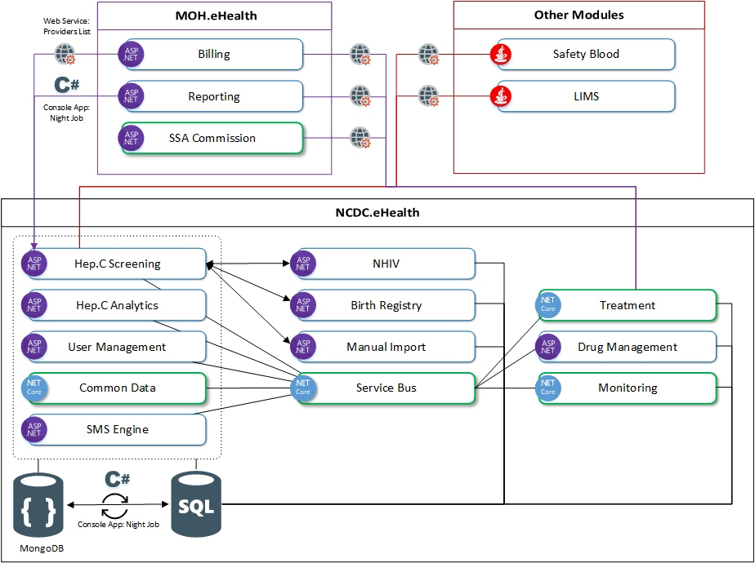
Figure 2 represents the architecture concept of the future ecosystem after development and implementation of Hepatitis C Treatment module.
Figure 2. Hepatitis C Program Ecosystem Future Vision
The changes into the ecosystem will be aimed to reach the following objectives:
- Decrease the module redundancy
- Improve the complete solution performance by:
  - Reducing inter-environment integrations
  - Improve inter-module integrations by connecting more modules to the Service Bus
    - Improve the Service Bus performance by upgrading the module to the up-to-date industry-standard technology (Microsoft .NET Core)
    - Upgrade Common Data module (shared data registry for all the modules) to Microsoft .NET Core
  - Redesign relevant modules to base them on the modern standard (Microsoft .NET Core)
- Technologically unify the complete solution farm by replacing php/mysql technology for the existing MOH.ElimC modules by Microsoft .NET platform.

System Modules / Components (TO BE)
Simultaneously with the creation and implementation of Hepatitis C Treatment module, the following changes will be applied to the ecosystem to fulfil the abovementioned objectives
- MOH.ElimC.Treatment
  - Will be revoked
  - Will be redeveloped on Microsoft .NET Core platform
  - Will be moved to NCDC.eHealth infrastructure
  - Will be connected to the ecosystem by Service Bus Module (.NET Core)
- MOH.ElimC.Commission
  - Will be revoked
  - The function of this module will be taken by the existing similar production module in MOH.eHealth environment (MOH.eHealth.Comission, Micorosft ASP.NET)
  - Will be connected to the ecosystem by Service Bus Module (.NET Core)
- MOH.ElimC.Drugs
  - Will be revoked
  - Will be redeveloped using existing Stock Management Engine (NCDC.eHealth.Stock, Microsoft ASP.NET)
  - Will be connected to the ecosystem by Service Bus Module (.NET Core)
- MOH.ElimC.Monitoring
  - Will be revoked
  - Will be redeveloped on Microsoft .NET Core platform
  - Will be moved to NCDC.eHealth infrastructure
  - Will be connected to the ecosystem by Service Bus Module (.NET Core)
- MOH.ElimC.mysql
  - Mysql database server will be revoked
  - All the data will be transferred to the existing Microsoft SQL Server (possible increase of the Server resources will be needed)
As the results of the changes the Hepatitis C ecosystem will be reshaped and will consist of the components described in the tables below (Table 5 and Table 6):

Table 5. NCDC.eHealth modules TO BE
Component | Platform/Language |  | Database |  | Location |  | Comment
NCDC.eHealth.Screening (Hepatitis C Screening) | ASP.NET Web Forms |  | Microsoft SQL / MongoDB |  | MoLHSA Virtual Machine
NCDC.eHealth.Analytics (Hepatitis C Analytics) | ASP.NET Web Forms |  | Microsoft SQL |  | MoLHSA Virtual Machine
NCDC.eHealth.Treatment (Elimination C Treatment) |  | .NET Core 2.1 |  | Microsoft SQL |  | MoLHSA Virtual Machine
NCDC.eHealth.Stock (Drug Management / Stock) |  | ASP.NET Web Forms |  | Microsoft SQL |  | MoLHSA Virtual Machine
NCDC.eHealth.Monitoring (Hepatitis C Monitoring) |  | .NET Core 2.1 |  | Microsoft SQL |  | MoLHSA Virtual Machine
NCDC.eHealth.SB (Service Bus / Messaging Module) | .NET Core 2.1 |  | Microsoft SQL |  | MoLHSA Virtual Machine
NCDC.eHealth.UM (User Management) | ASP.NET Web Forms |  | Microsoft SQL |  | MoLHSA Virtual Machine |  | Custom authentication method (similar to oAuth)
NCDC.eHealth.CM (Common Data) | .NET Core 2.1 |  | Microsoft SQL |  | MoLHSA Virtual Machine
NCDC.eHealth.SMS (SMS engine) | ASP.NET Web Forms |  | Microsoft SQL |  | MoLHSA Virtual Machine
NCDC.eHealth.NHIV (NCDC NHIV Module) | ASP.NET Web Forms |  | Microsoft SQL |  | MoLHSA Virtual Machine
NCDC.eHealth.BR (NCDC Birth Registry) | ASP.NET Web Forms |  | Microsoft SQL |  | MoLHSA Virtual Machine

Table 6. MOH.eHealth modules TO BE
Component | Platform/Language |  | Database |  | Location |  | Comment
MOH.eHealth.Billing (Billing Module) | ASP.NET Web Forms |  | Microsoft SQL / MongoDB |  | MoLHSA Virtual Machine
NCDC.eHealth.Reporting (Reporting Module) | ASP.NET Web Forms |  | Microsoft SQL |  | MoLHSA Virtual Machine
MOH.ElimC.Commission (SSA Commission) | ASP.NET Web Forms | Microsoft SQL |  | MoLHSA Virtual Machine

The other connected modules (Table 4) will be unaffected.
Besides the above changes, other libraries will be redesigned using Microsoft .NET Core 2.1 platform:
  - NCDC.eHealth.Tools
  - NCDC.eHealth.Cash
  - NCDC.eHealth.Contracts
  - NCDC.eHealth.Proxies
  - NCDC.eHealth.Services

Integrations and dependencies

Internal Integrations
Inter-ecosystem integrations will be realized by two methods, depending on the data and business process:
- Via Integration module (Service Bus)
- Via Console application (Night Job)
Current inter-ecosystem information flows are described below:
- MOH.Elims.mysql – NCDC.eHealth.SQL
  - Method: Console App (C#) / Night Job
  - Data: Only data needed for analytics (24 tables)
  - Period: Every Day
- NCDC.eHealth.MongoDB - NCDC.eHealth.SQL
  - Method: Console App (C#) / Night Job
  - Data: Form and collection data
  - Period: Every Day
- MOH.eHealth.Billing – NCDC.eHealth.Screening
  - Method: Web Service / WCF
  - Data: Providers List
  - Period: Once in 30 minutes
- MOH.eHealth.Reporting – NCDC.eHealth.Screening
  - Method: Console App (C#) / Night Job
  - Data: Form 066 data, where screening event is completed.
  - Period: Every Day
- NCDC.eHealth.BirthRegistry – NCDC.eHealth.Screening
  - Method: Console App (C#) / Night Job
  - Data: List of the Persons with positive result
  - Period: Every Day
- NCDC.eHealth.NHIV – NCDC.eHealth.Screening (Planned)
  - Method: Web Service / WCF
  - Data: Information about laboratory sample
  - Period: Per Request
- MOH.Elim.C - NCDC.eHealth.Screening
  - Method: Web Service / WCF
  - Data: Sends Personal ID / Receives whether screening test is done (Yes/No)
  - Period: Per request
- NCDC.eHealth.Screening - MOH.Elim.C
  - Method: Web Service / WCF
  - Data: Receives Blood sample with confirmation test results
  - Period: Per request

Internal Dependencies
The modules that provide shared services for the Hepatitis C ecosystem are the following:
- Service Bus
  - Will act as an integrations module for all the connected modules (see “Internal Integrations” above)
- Common Data
- User Management
- Hepatitis C Analytics

External Integrations
External integrations will be realized by two methods, depending on the data and business process:
- Via Web-services
- Via Console application (Night Job)
Current external information flows are described below:
- Other.SafeBlood – NCDC.eHealth.Screening
  - Method: Web Service / WCF
  - Data: List of the Persons with positive result
  - Period: Every Day (?)
- Other.LIMS – NCDC.eHealth.Screening
  - Method: Web Service / WCF
  - Data: List of the Persons with positive result
  - Period: Every Day (?)

Data Access and User Roles
User roles and rights administration will be provided by the existing User Management Module (NCDC.eHealth.UM). The user roles are defined as below:
- Super Administrator
- Administrator (per module)
- User (per module)
  - Treatment user
  - Screening user
  - Analytics user
  - Manual Import user
  - Drug Management user
  - Monitoring User
Several users may simultaneously have several roles, for example one user may be Treatment and Screening user at the same time.
As for the Hepatitis C Treatment users, there will be several defined roles for Separately Governmental Organizations and Healthcare Service Provider Organizations.
- Governmental Organizations:
  - System Administrator
  - SSA – Registration role
  - SSA – Regional Registration role
  - NCDC – Registration role
  - Committee Member Role
  - Drug Registration Role
  - Drug Distribution Role
  - Drug Logistics Role
- Healthcare Service Provider Organization
  - Reception
  - Laboratory
  - Physician
  - Medication Distributor
  - Manager

Process Workflow
Current treatment process starts with the positive screening result and involves several components:
- Anti HCV Screening
  - Diagnostic Provider
- Treatment Provider
  - Diagnostic Component
  - Monitoring Component
- Social Service Agency
  - SSA Committee
  - SSA Stock
  - SSA eHealth
Figure 3 Presents Business-process workflow of the currently operating Elimination C System.
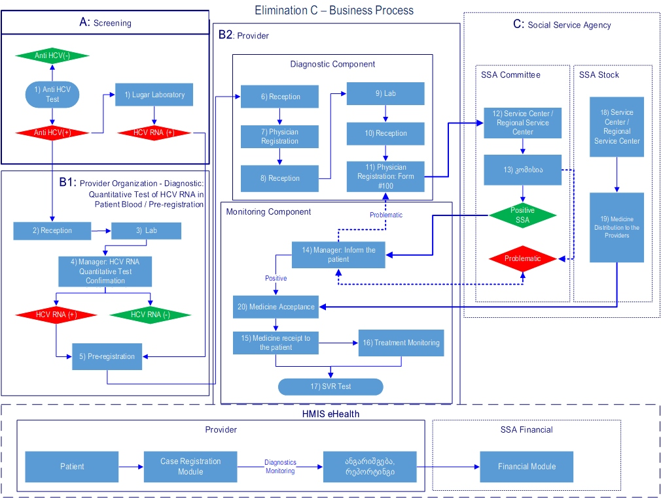
Figure 4 presents future high-level business-process connections inside the integrated Elimination C system.
Figure 3. Hepatitis C Treatment Business-Process workflow AS IS

Data link to Analytics Module
Data link to the analytics module is realized by means of a Console Application (Night Job). The role of this application is to transfer the data and transform the data structure from MongoDB database to Microsoft SQL Database, which will act as a data warehouse for the analytical reports and dashboards. MongoDB database itself act as a data collection point for Hepatitis C Screening module, which accumulates the data from various connected modules (see chapters “Internal Integrations” and “External Integrations”).
More technical details about Analytical Module is Described in the Document “Hepatitis C Data Analytics – Solution Architecture” .
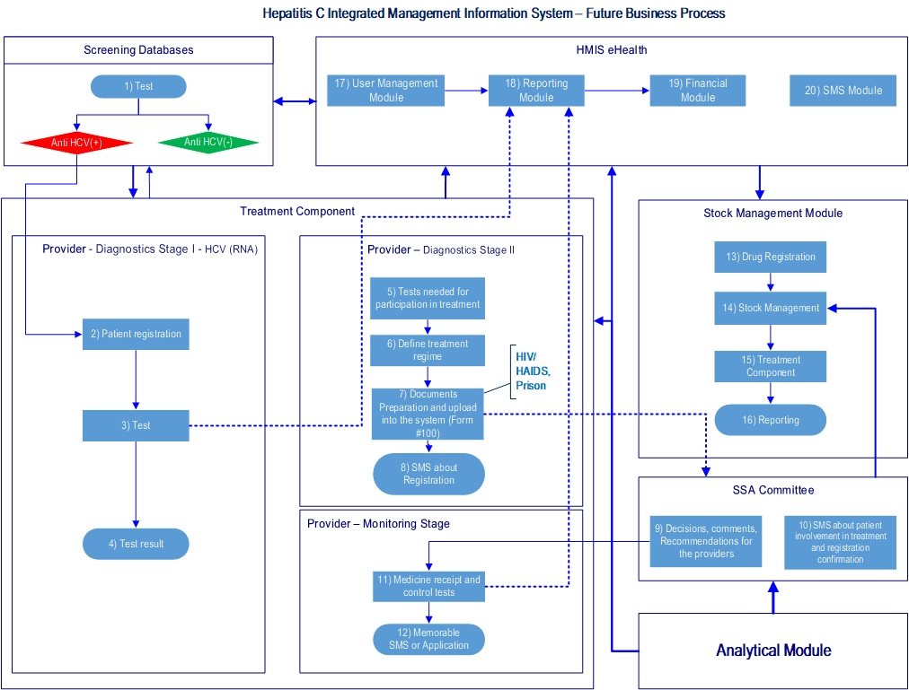
Figure 4. Hepatitis C Integrated Management Information System - Future Vision
More technical details about Analytical Module is Described in the Document “Hepatitis C Data Analytics – Solution Architecture” .

Hardware / Software Requirements
Hardware Requirements for each of the components that will be developed or redeveloped:
- CPU: 8x – 2000Mhz
- RAM: 32GB
- HDD: 500GB
Requirements to the software Environment
- Microsoft Windows Server 2008 R2
- Microsoft Information Services (IIS)
- Microsoft Visual Studio.Net 2010/2012/2013
- Microsoft ASP.NET, Microsoft .NET Core 2.1., DevExpress UI Controls, Microsoft Chart Controls
- NHibernate-compatible Database (Microsoft SQL, postgreSQL, MongoDB)

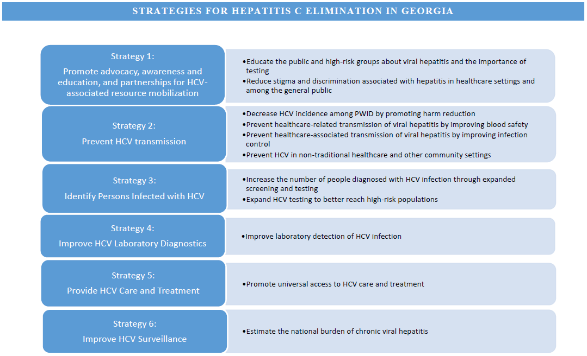
Appendix A
Figure 5. Strategies for Hepatitis C Elimination in Georgia

Appendix B
Table 7. Data Dictionary for the new Hepatitis C Treatment Integrated Solution
Category | Variable | Variable type | Definition | Description
Personal information | Target group | ComboBox | Examples: General population, Pregnant women, Patients on hemodialysis treatment, Prisoners, Blood donors, Students, TB patients, Soldiers, Hospitalized patients, Patients on drug therapy, Other risk groups | Registration for all these targets groups - with 11 digit ID number
Personal information | Personal number | TextBox |  | 11 digit Personal ID number
Personal information | 15 digit code | TextBox | For Harm Reduction Network, target group is: Other risk groups (registration with 15-digit number). System requires ID number only when HCV test result is positive. | 15 digit code
Personal information | last Name | TextBox |  | Patient’s surname
Personal information | First Name | TextBox |  | Patient’s name
Personal information | Date of birth | Date | DD-MM-YYYY Format | Patient’s date of birth
Personal information | Gender | ComboBox | Male/Female | Patient's sex
Personal information | Age | Textbox |  | Patient's age
Personal information | Phone | Textbox |  | Patient's mobile number
Personal information | Code | Textbox |  | code is generated randomly by the system and is used for blood sample only in a laboratory
Personal information | Source |  | Birth registry, 066, Blood bnk, C elimination, Evex, Excel, Stop C old, soldiers, Harm Reduction Network, Tbilisi City hall, Module manually filed, Center laboratories, Prisons | Data source
Personal information | Address | Textbox |  | Patient's address by Public Registry (country, city, region, raion, muniqueipality and street)
Personal information | Note | Text
Personal information | Region | ComboBox | Examples: Adjara, Guria, Tbilisi | Patient's actual address Region
Personal information | Raion | ComboBox |  | Patient's actual address Raion
Personal information | Muniqueipality | ComboBox |  | Patient's actual address Muniqueipality
Personal information | Street | Textbox |  | Patient's actual address street
Screening test | Target group for screening tests (HCV, HIV) | ComboBox | Examples: General population, Pregnant women, Patients on hemodialysis treatment, Prisoners, Blood donors, Students, TB patients, Soldiers, Hospitalized patients, Patients on drug therapy, Other risk groups
Screening test | Study material | ComboBox | Saliva, Blood | Test materials: Blood or Saliva for screening tests (HCV)
Screening test | Research method | ComboBox | Immunochromatography-rapid test, Immunoferment, Others | Test method
Screening test | (HCV) research result | ComboBox | Positive, Negative | HCV Test result
Screening test | (HCV) Check date | Date | DD-MM-YYYY Format | Date when the test was done
Screening test | (HCV) The date of input | Date | DD-MM-YYYY Format | Date when the results were entered into the system
Screening test | Source |  | Birth registry, 066, Blood bnk, C elimination, Evex, Excel, Stop C old, soldiers, Harm Reduction Network, Tbilisi City hall, Module manually filed, Center laboratories, Prisons | Data source
Screening test | Study material | ComboBox | Saliva, Blood | Test materials: Blood or Saliva for HIV screening test
Screening test | Research Method | ComboBox | Immunochromatography-rapid test, Immunoferment, Others | Test method for HIV screening test
Screening test | (HIV) research results | ComboBox | Positive, Negative | HIV Test result
Screening test | (HIV) check date | Date | DD-MM-YYYY Format | Date when the test was done
Screening test | (HIV) The date of input | Date | DD-MM-YYYY Format | Date when the results were entered into the system
Screening test | Source |  | Birth registry, 066, Blood bnk, C elimination, Evex, Excel, Stop C old, soldiers, Harm Reduction Network, Tbilisi City hall, Module manually filed, Center laboratories, Prisons | Data source
Screening test | Provider Name | TextBox |  | Provider name, which is doing the screening tests
Screening test | Provider Tax | TextBox |  | Provider Tax, which is doing the screening test
Screening test | Provider Region | TextBox | Examples: Adjara, Guria, Tbilisi | Provider Region, which is doing the screening test
Data related to taking sample for confirmation test | Taking the blood sample | ComboBox | Mandatory Field. List: Sample is taken, Sample is not taken | Variable, which defines sample was taken or not for confirmation test
Data related to taking sample for confirmation test | Comment (denial, reason) | TextBox |  | Field is active when "Sample is not taken" is chosen. User's comment/reason, why sample has not been taken for confirmation test
Data related to taking sample for confirmation test | Sample type | ComboBox | Mandatory field. List:  Plasma, Serum | Field is active when "Sample is taken" is chosen. Sample type for confirmation test
Data related to taking sample for confirmation test | Date of sample taking | Date | Mandatory field. DD-MM-YYYY Format | Date of taking sample for confirmation test
Data related to taking sample for confirmation test | Time of sample taking | Time | Mandatory field. Time- Minute Format | Time of taking sample for confirmation test
Data related to taking sample for confirmation test | Registration date of sample taking related information | Date/Time | DD-MM-YYYY/ Time- Minute Format | Date/time of sample taking for confirmation test, which is recorded automatic in database
Data related to taking sample for confirmation test | Barcode | TextBox | Y/HCV/ 000… | unique Number/Barcode of sample generated by the system, which is used afterwards in Lugar Laboratory Information Management System (LIMS) to identify and synchronize sample related information
Data related to taking sample for confirmation test | Sample identification number (given by the provider) | TextBox | Mandatory Field. | Identification number of sample for confirmation test, given by the medical facility
Data related to taking sample for confirmation test | Ready to be sent to Lugar Laboratory | CheckBox | Mandatory Field. | Field is active/checked when the sample for confirmation test is ready to be transported to Lugar Laboratory
Data related to taking sample for confirmation test | Registration date of " Ready to be sent to Lugar Laboratory" | Date/Time | DD-MM-YYYY/ Time- Minute Format | Date is automatically registered in database, when "Ready to be sent to Lugar Laboratory" is active/checked
Data related to taking sample for confirmation test | Client's Personal Number | TextBox | Mandatory Field. | Client's personal 11 digit number, synchronized with the Civil Registry
Data related to taking sample for confirmation test | Client's Name | TextBox | Mandatory Field. | Client's Name, synchronizes with the Civil Registry with personal 11 digit number
Data related to taking sample for confirmation test | Client's Surname | TextBox | Mandatory Field. | Client's Surname. synchronizes with the Civil Registry with personal 11 digit number
Data related to taking sample for confirmation test | Client's Telephone Number | TextBox | Mandatory Field. | Client's telephone number (9 digit number)
Data related to taking sample for confirmation test | Email of sample sender facility | TextBox |  | Email of medical facility who ordered the confirmation test
Data related to taking sample for confirmation test | Telephone number of beneficiary/Legal representative (number where result of confirmation test will be sent) | TextBox | Mandatory Field. | Telephone number of beneficiary/Legal representative (number where result of confirmation test will be sent)
Data related to taking sample for confirmation test | Emil of beneficiary/Legal representative (number where result of confirmation test will be sent) | TextBox |  | Emil of beneficiary/Legal representative (number where result of confirmation test will be sent)
Data related to receiving sample for confirmation test | Date of receiving sample | Date | Mandatory field. DD-MM-YYYY Format | Date of receiving sample for conformation test in Lugar laboratory (or different user)
Data related to receiving sample for confirmation test | Time of receiving sample | Time | Time- Minute Format | Time of receiving sample for conformation test in Lugar laboratory (or different user)
Data related to receiving sample for confirmation test | Sample condition | ComboBox | Mandatory Field. List: Satisfying and unsatisfying | Condition of sample taken for confirmation test in Lugar Laboratory (or different user)
Data related to receiving sample for confirmation test | Comment regarding sample quality | TextBox |  | Comment regarding condition of sample taken for confirmation test in Lugar Laboratory (or different user)
Result of Confirmation test | Conducted Test | ComboBox | List: HCV Cor Antigen,HCV PCR quantitative ,HCV PCR qualitative | Name of conducted Test
Result of Confirmation test | Test method/used test system | ComboBox | List: Abbott Architecht,Abbott HCV,GeneXpert HCV, other | Test method/used for confirmation
Result of Confirmation test | Test result | TextBox |  | Confirmation test result
Result of Confirmation test | Test Unit | TextBox |  | Confirmation test unit, is filled automatic based on test method (fmol/L, IU/ml )
Result of Confirmation test | Acceptable range | ComboBox | List: < 3 fmol/L,≥3 <10 fmol/L,≥ 10 fmol/L,0,<12 IU/ml,<30 IU/ml,≥12 IU/ml,≥30 IU/ml,Not found, Dubious,Found | Acceptable ranges according to confirmation test and test methods
Result of Confirmation test | Laboratory Interpretation | ComboBox | List: negative, Marginal Value, Positive, Not found, Found, Test result is lower tha Marginal Value, Test can not provide precise answer | Laboratory Interpretation according to confirmation test, test methods and ranges
Result of Confirmation test | Result Interpretation/Comments | ComboBox | List: Confirmation with PCR test, Involvement in treatment, Negative, Acute infection is not confirmed, Retest after 90 days, Acute infection is confirmed by the laboratory, Beneficiary requires treatment | Result Interpretation/Comments according to confirmation test, test methods and ranges
Result of Confirmation test | Comment - Test result | TextBox |  | Comment regarding confirmation test
Result of Confirmation test | Test Performer | TextBox |  | Name and surname of test performer
Result of Confirmation test | Test Checker | TextBox |  | Name and surname of the person who checked test related information into the system
Result of Confirmation test | Date of test registration | Date |  | Date of test registration
Result of Confirmation test | Time of test registration | Time |  | Time of test registration
Result of Confirmation test | Link of printing form | TextBox |  | Link of printing form, where from test result is printed registered in LIMS
Data related to taking sample for confirmation test | User/Provider | TextBox |  | Address and Code of User/Provider, which took sample for confirmation test
Data related to taking sample for confirmation test | Region of User/Provider | TextBox |  | Region of User/Provider which registered taking sample for confirmation test into the system
Data related to taking sample for confirmation test | Transportation status | ComboBox | List: None, To be taken, Taken | Transportation status given by NCDC user
Data related to taking sample for confirmation test | Date of transportation status | Date |  | Date of changing transportation status
Data related to taking sample for confirmation test | Case status | TextBox |  | Case status. If the field is empty it means that patient does not have confirmation test. If "Confirmation test is performed" is chosen, it means that beneficiary has already received similar service within the state Hepatitis C program.

Strategic Plan for the Elimination of Hepatitis C Virus in Georgia, 2016-2020
3.1.3. Improve information systems to promote linkage to care and treatment for persons testing positive for HCV. a) Develop, implement, and maintain a testing registry and integrate with Hepatitis C to facilitate linkage to care among persons with positive HCV test results.
Link to the Analytics technical document (will be added later)
Link to the Analytics technical document (will be added later)
https://technet.microsoft.com/en-us/library/dd349801(v=ws.10).aspx
https://www.iis.net
https://www.visualstudio.com

